Spring is Here- It’s Time!
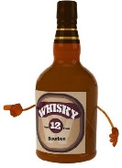
Saint Joseph Wine & Bourbon Tasting
Parish Life Center
(268 Grove Street, Oradell)

Saturday – April 27, 2024
7:30 – 10:30 PM
$60 per person
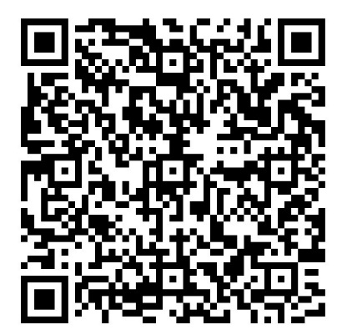
Beer, soda, water and finger foods included

Proceeds to benefit St. Joseph Church
Use the QR code to register on line OR use the form below and drop off or mail the Reservation Form with check to:
St. Joseph Church
105 Harrison St. New Milford, NJ 07646
Attn: Wine & Bourbon

RSVP April 24th
Questions? Contact: Tom Kohli - tkohli@optonline.net or 201-669-2473
Permit # 112999
----------------------------------------------------------------------------------------------------------------------------------------------------------------
St. Joseph Wine & Bourbon Reservation Form
Permit #112999

Name ____________________________________________________ Email: _________________________________

Address ___________________________________________________________________________________________

Phone: _________________________________________

Number Attending: _______ X $60 Total ____________ Address checks to: St. Joseph Church
(must be 21 years of age or older to attend) For: Wine & Bourbon

