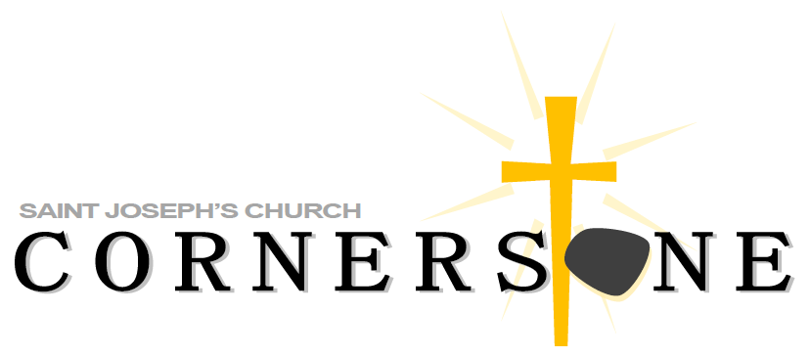

Men’s Cornerstone XXXI

March 21 & 22, 2025

All Are Welcome!

**What is Cornerstone?**

Cornerstone is a retreat presented annually by parishioners with the intent to build each participant’s spirituality and to connect them with the St. Joseph’s community.

It is called “Cornerstone” referring to Christ being the Cornerstone, the foundation upon which our lives are built. On the weekend, you will experience a focused atmosphere where you can initiate, deepen or revitalize your relationship with Christ, in a welcoming environment.

Many of us attend Mass, but because of our busy lives, find it hard to connect to our community of faith and have a close connection with others in our parish. Spending this time at a Cornerstone retreat will give you the opportunity to make these connections with God, and with others.

**Who Can Attend Cornerstone?**

St. Joseph’s Cornerstone is open to men and women of all Christian faiths and is held annually (one for men and one for women). You may wish to invite a family member or friend to attend with you.

**When is Cornerstone?**

**Men’s date – March 21st & 22nd 2025**

**Who Conducts This Retreat?**

A team of dedicated parishioners who have made Cornerstone and want to pass the gift on to others will present the weekend. Leading each team (Men’s & Women’s) is a Director and Facilitator, under the spiritual direction of Fr. Christian Scalo & Fr. John Radwan.

**What Will I Experience on the Weekend?**

The retreat takes place in St. Joseph’s Retreat House and begins at 7 p.m. on Friday evening. All meals (lovingly prepared), and plenty of snacks will be provided.

The weekend activities will help you to affirm your own gifts and discover how you can use these gifts for the good of others. It is a fun way for church members to get to know each other and build lasting bonds of support and trust.

There are short presentations followed by small group discussions, quiet personal time, and Reconciliation. Everything shared on the weekend is held in strict confidence. There is also time for fun and relaxation. The weekend concludes with a Family Mass at 8 p.m. on Saturday evening. Family and friends are invited to attend. This is a weekend of great surprises, prepared especially for YOU! Every team member is dedicated to ensuring an atmosphere of warmth and hospitality.

**How Do I Register?**

To register, simply fill out this Form and drop it in the rectory in the box provided. Or you can call or email information below to the Sign-Up Coordinators listed at the bottom.

**NAME**

**NAME FOR NAMETAG**

**ADDRESS**

**CITY, STATE, ZIP**

**HOME PHONE#**

**CELL PHONE#**

**EMAIL**

**CONTACT NAME (family member or close friend)**

**CONTACT ADDRESS & PHONE # (if different)**

**CONTACT EMAIL ADDRESS**

**PLEASE RETURN TO:**

**St. Joseph’s Rectory**

**105 Harrison Street**

**New Milford, NJ 07646**

**Or Email information to:** **[mcornerstone@sjcnj.org](mailto:mcornerstone@sjcnj.org)**

As soon as possible. Preferably no later than 1 week before the weekend to allow us time to adequately prepare for you. Thank You!

CORNERSTONE MISSION STATEMENT

As brothers and sisters in Christ, the St. Joseph Cornerstone community invites men and women to enrich their faith and life as a Christian through a spiritually moving annual retreat.

Guided by the Holy Spirit, we discover our individual gifts and how we can use them for the good of our parish and greater community. Through the retreat and continued gatherings, we build lasting bonds of support, trust, and friendship in an atmosphere of warmth and hospitality.

**For additional information or To Register call or email:**

[**mcornerstone@sjcnj.org**](mailto:mcornerstone@sjcnj.org)

**Ralph Mastrangelo OR Rich Ciero**

**(201) 634-9539 (845) 558-1938**