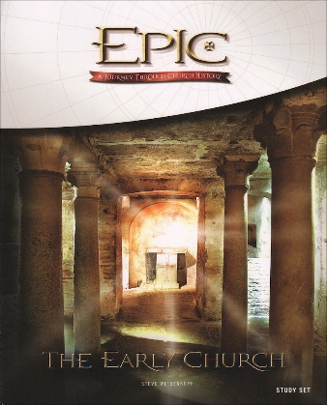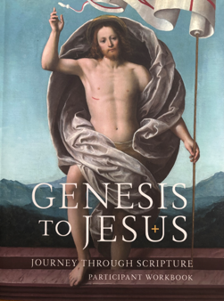

Bible Study/Adult Faith Formation Registration Fall 2026

Name: _____________________________________________________

Address: ___________________________________________________

Town: _____________________________________ Zip: _____________

Email: ______________________________________________________

Cell Phone #: ___________________ Home Phone#: _________________

Genesis to Jesus (12 wks)
____Tuesday 7:00-8:30PM Other (state time/day preference _________________

Epic: The Early Church (10 wks)
____ Monday 11:00 AM-12:30PM
____Tuesday 9:30-11:00AM

Epic: A Journey into Church History (20 wks)
____ Monday 8:00-9:30PM
____Tuesday 12:30-2:00PM

Other times are possible. Please let us know what days/times will work for you:
_____________________________________________________________________________
Registration Fee (includes Study Guide):
Fee for All studies - $35

Payment: Amount ______Cash ___ Check ___ (Checks made out to St. Joseph Church)

Form may be dropped off at the rectory or mailed to:
St. Joseph Church, 105 Harrison St, New Milford, NJ 07646
For more info email bible@sjcnj.org DEADLINE SEPTEMBER 7

